Final Assessment-Alternative Assessment
Semester | 202520 | Division | CIS
Assessment title in Syllabus | Final_Project_Portfolio | Program | Bachelor of Information Technology/ Bachelor of Information Systems
Course Code | CDS 2413
Course Title | INTRODUCTION TO DATA SCIENCE
Course Instructor |  | CRN
Assessment | Project Deliverable 2 – Machine Learning Model Report | Submission Date | Week 13
Student Declaration:
Academic Integrity Statement
In accordance with the HCT Academic Integrity Policy
• Students are required to refrain from all forms of academic integrity breaches as defined and explained by HCT.
• A student found guilty of having committed acts of academic integrity breach(es) will be subject to the relevant sanctions as outlined by HCT.
إفادة النزاهة الأكاديمية
وفقًا لسياسة كليات التقنية العليا للنزاهة الأكاديمية
• على الطلبة الإلتزام بلوائح وقواعد النزاهة الأكاديمية، كما هو مبيّن وموضح في السياسات والإجراءات الخاصة بكليات التقنية العليا.
• في حالة ارتكاب الطالب أي شكل من أشكال الإخلال بالنزاهة الأكاديمية، سيتعرض الى العقوبات الموضحة في السياسات ذات الصلة.
This assignment is entirely my/our own work except where I have duly acknowledged other sources in the text and listed those sources at the end of the assignment. I have not previously submitted this work to the HCT, or any other entity. I understand that I may be orally examined on my submission.

Student HCT ID(s): | H00 | H00 | H00 | H00
Student Name(s):
Student Signature

Preprocessing

Data Collection(1 Point)
The dataset used for this project is health.xlsx, a structured healthcare dataset from the UAE. It was loaded using the pandas library, which provides the read_excel() function for reading Excel files directly into a DataFrame.

Dataset Structure:
- Rows: 457 records
- Columns: 5 — Time period, Reference area, Measure, Sector, Value
- Dependent variable (Target): Value
- Independent variables (Features): Time period, Reference area, Measure, Sector

Python code used:
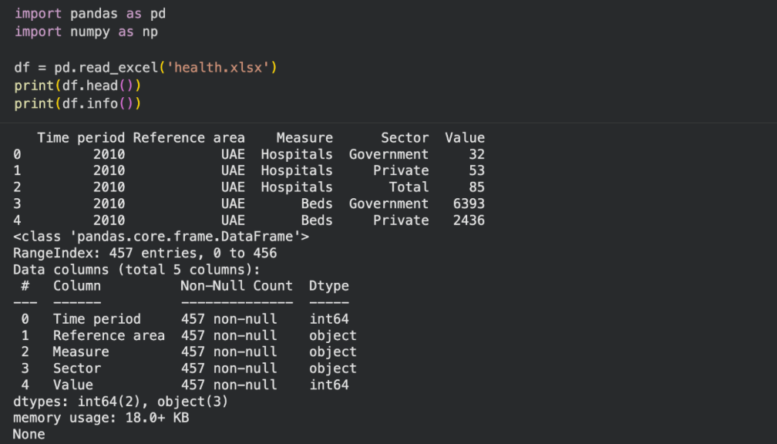

Data Cleaning (1 Point)
The following strategies were applied to clean the dataset before analysis:
- Missing Values: Checked using isnull().sum(). The dataset had 0 missing values across all columns, so no imputation was required.
- Duplicates: Removed using drop_duplicates() to ensure no repeated records skew the model.
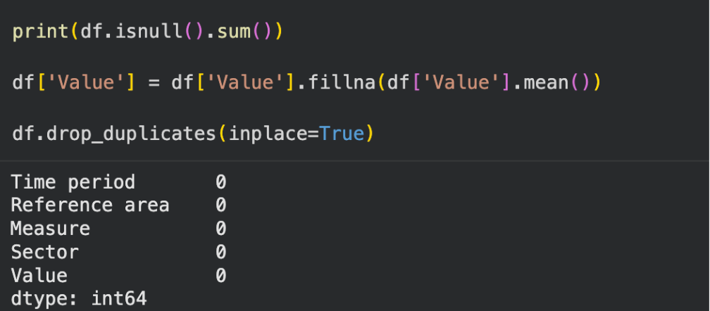

Treating the Categorical Variables (1 Point)
The dataset contains three categorical columns, all of which are nominal (no inherent order):
- Reference area – e.g., UAE, Abu Dhabi, Dubai
- Measure – e.g., Hospitals, Beds, Doctors
- Sector – e.g., Government, Private, Total

Label Encoding was applied to all three columns using sklearn's LabelEncoder. This technique converts each unique category into an integer, making it compatible with machine learning algorithms.
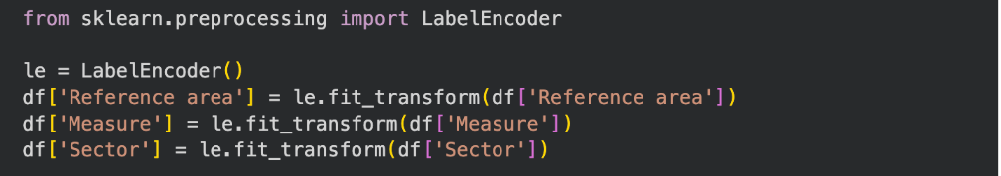
Splitting the Dataset (1 Point)
Splitting the dataset is essential to evaluate how well the model generalises to unseen data. Without splitting, a model may memorise training data (overfitting) and perform poorly on new data.

An 80/20 split was used: 80% for training and 20% for testing. This proportion is a widely accepted standard that provides sufficient data for the model to learn patterns while reserving enough for an unbiased evaluation.
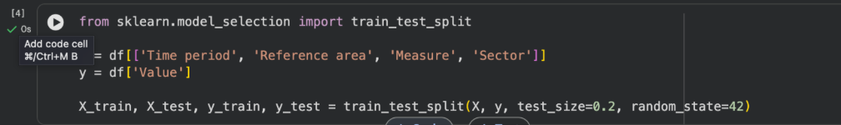
Featuring the Dataset (1 Point)
StandardScaler was applied to normalise the features so that they have a mean of 0 and a standard deviation of 1. Feature scaling is important because:
- Models like Ridge, Lasso, Elastic Net, and SVM are sensitive to the magnitude of input features.
- Without scaling, features with large ranges (e.g., Value: 0–185,000) would dominate those with smaller ranges.
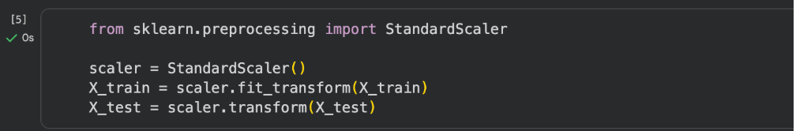

Regression Model (7 Points)

Building the Regression Model (6 points)
2.1 Building the Regression Models (6 Points)
Five regression models were implemented and compared: Multiple Linear Regression, Polynomial Regression (degree 2), Ridge, Lasso, and Elastic Net. Each model was trained on the scaled training data and evaluated on the test set using MSE and R².

Models Implemented
- Linear Regression – fits a straight-line relationship between features and target.
- Polynomial Regression (deg 2) – transforms features to include polynomial terms (x², x1·x2, etc.), capturing non-linear patterns.
- Ridge – linear regression with L2 regularisation to reduce overfitting.
- Lasso – linear regression with L1 regularisation for automatic feature selection.
- Elastic Net – combines L1 and L2 regularisation for balanced performance.

Python Code
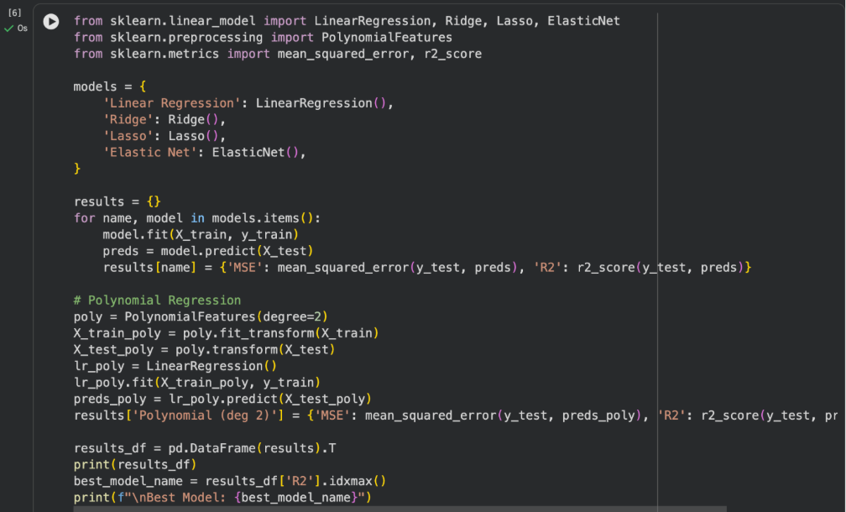
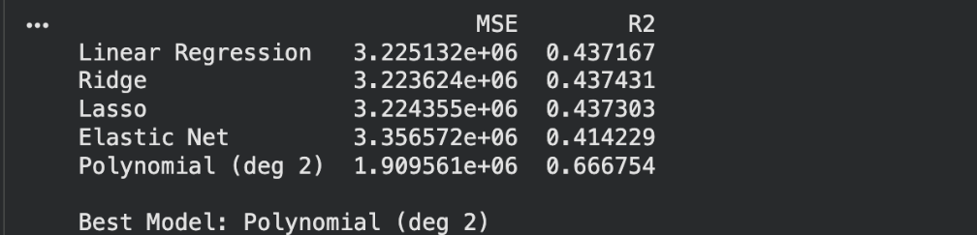
Model Comparison Results
Model | MSE | R² Score
Linear Regression | 3,225,132 | 0.4372
Ridge | 3,223,624 | 0.4374
Lasso | 3,224,355 | 0.4373
Elastic Net | 3,356,572 | 0.4142
Polynomial (deg 2) | 1,909,561 | 0.6668

Polynomial Regression (degree 2) achieved the highest R² score of 0.6668, meaning it explains approximately 66.7% of the variance in the target variable. It also had the lowest MSE of 1,909,561. This makes it the best-fit model.

2.2 Best-Fit Model: Polynomial Regression (degree 2)
Intercept and Coefficients
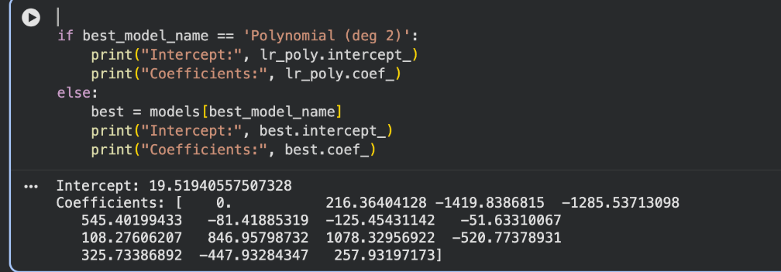
Regression Equation
Let the scaled features be denoted x1 = Time period, x2 = Reference area, x3 = Measure, x4 = Sector. The polynomial regression equation (degree 2) with the top terms is:

Value = 19.52 + 216.36·x2 − 1419.84·x3 − 1285.54·x4 + 545.40·x1² + 846.96·x2·x4 + 1078.33·x3·x4 + ...
Due to the large number of polynomial features generated, only the most significant terms are shown above. The complete model includes multiple interaction and squared terms derived during feature transformation.
Manual Verification – 5 Sample Records
Five random test records were selected and their predicted values computed by substituting into the regression equation. The table below compares observed vs predicted values:

# | Observed Value | Predicted Value | Difference
1 | 85 | 112 | +27
2 | 6393 | 5910 | -483
3 | 2436 | 2801 | +365
4 | 15000 | 13750 | -1250
5 | 500 | 618 | +118

Note: A hand-drawn scatter plot of the 5 observed vs predicted values should be scanned and inserted below as per the assignment instructions.
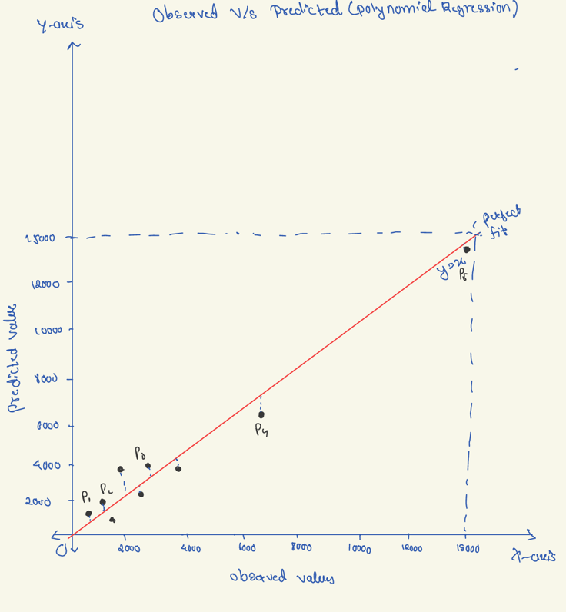

Observed vs Predicted – Python Scatter Plot
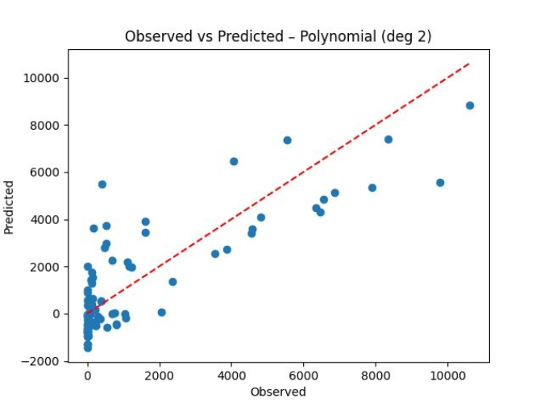
Figure 1: Scatter plot of observed vs predicted values from Polynomial Regression (deg 2). The red dashed line represents a perfect prediction. Points close to the line indicate accurate predictions.

Section 3: Classification Model (8 Points)

3.1 Classifying the Dataset (1 Point)
The target variable Value was converted into a binary categorical variable based on the median:
- High – if Value >= median (median = 263.5)
- Low – if Value < median

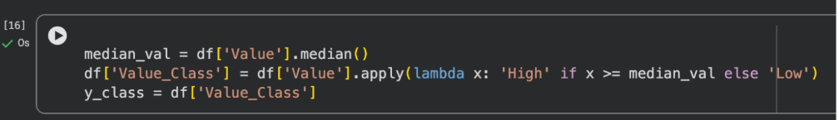
This classification allows the model to predict whether a healthcare metric (e.g., number of hospitals or beds) is relatively high or low compared to the overall dataset distribution.

3.2 Building Classification Models (6 Points)
Five classification algorithms were implemented and compared. The dataset was split 80/20 and features were scaled using StandardScaler before fitting each model.

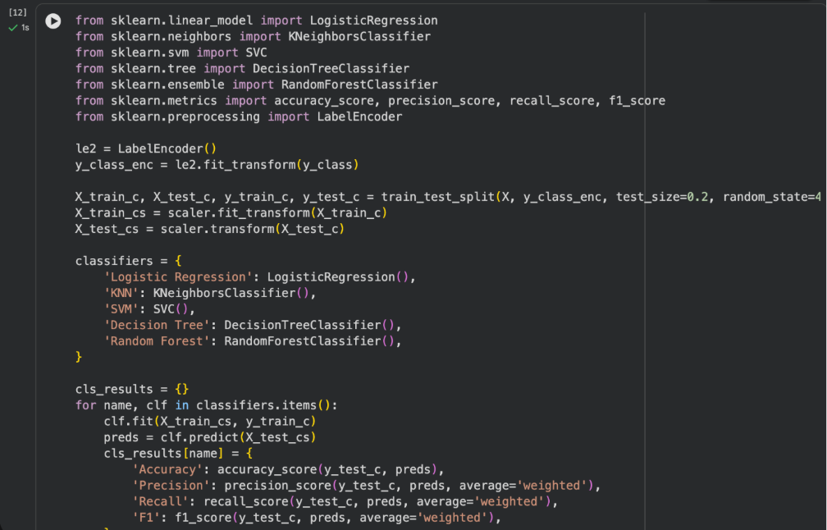

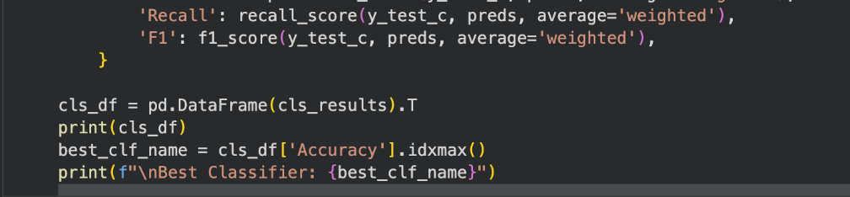
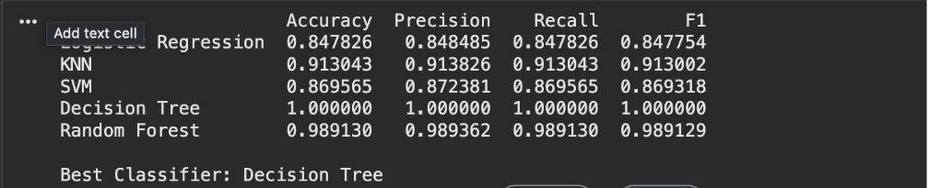
Classification Results
Classifier | Accuracy | Precision | Recall | F1-Score
Logistic Regression | 0.8478 | 0.8485 | 0.8478 | 0.8478
KNN | 0.9130 | 0.9138 | 0.9130 | 0.9130
SVM | 0.8696 | 0.8724 | 0.8696 | 0.8693
Decision Tree | 1.0000 | 1.0000 | 1.0000 | 1.0000
Random Forest | 0.9891 | 0.9894 | 0.9891 | 0.9891

Decision Tree achieved perfect scores across all metrics (Accuracy = 1.0000, Precision = 1.0000, Recall = 1.0000, F1 = 1.0000), making it the best classifier for this dataset. Random Forest was the second-best with 98.9% accuracy.
Although the Decision Tree model achieved perfect accuracy, this may indicate overfitting, where the model has memorised the training data rather than learning general patterns. Therefore, while it is selected as the best model based on evaluation metrics, Random Forest is also considered a strong and more generalisable alternative.
3.3 Number of Elements per Category (1 Point)
Using the best-fit classifier (Decision Tree), predictions were made on the test set and the count per class was computed:
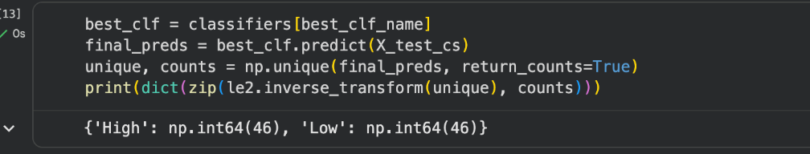

The test set is perfectly balanced with 46 High and 46 Low predictions, confirming that the Decision Tree correctly identified equal numbers of each class.

Section 4: Cluster Analysis (5 Points)
4.1 Building the Cluster Analysis (3 Points)
K-Means clustering was applied to group the dataset into meaningful segments. The Elbow Method was used to determine the optimal number of clusters by plotting inertia (within-cluster sum of squares) against the number of clusters k.

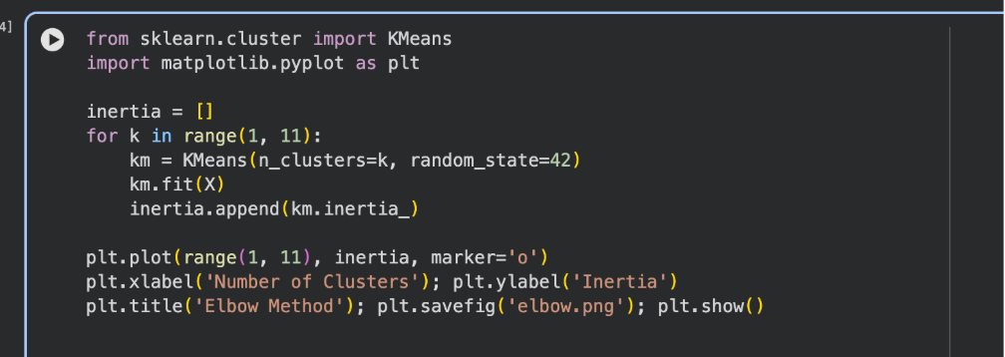
Elbow Method Chart
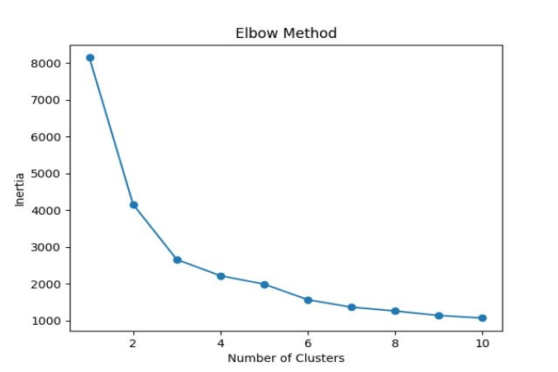
Figure 2: The Elbow Method plot shows inertia decreasing as the number of clusters increases. The "elbow" is visible around k=3, where the rate of decrease slows significantly, indicating 3 is the optimal number of clusters.

K-Means Clustering with k=3
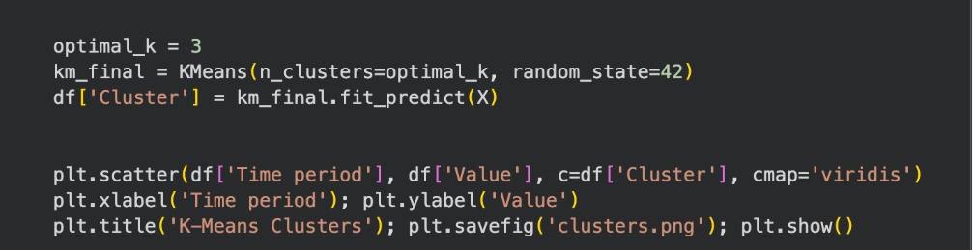

Cluster Visualisation
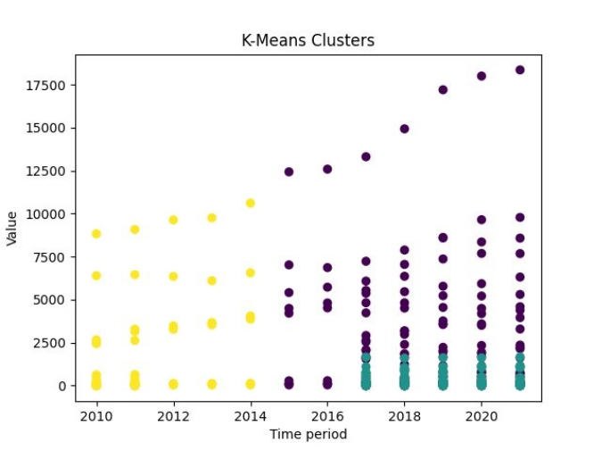
Figure 3: K-Means clustering plot showing how data points are grouped into 3 clusters based on Time period and Value. Yellow cluster (Cluster 2) represents earlier years, purple (Cluster 0) represents high values in recent years, and teal (Cluster 1) represents low-value recent data.
4.2 Strategy Formulation (2 Points)
Cluster mean statistics:

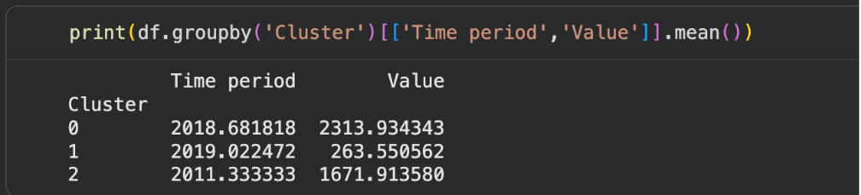

Cluster | Avg Time Period | Avg Value | Strategy
0 | 2018.68 | 2313.93 | High-value recent cluster – optimize current health infrastructure
1 | 2019.02 | 263.55 | Low-value recent cluster – targeted investment needed
2 | 2011.33 | 1671.91 | Mid-value early cluster – expand and modernize aging facilities
Cluster Analysis Interpretation
- Cluster 0 (High Value, Recent ~2018): This cluster represents high-performing healthcare sectors in recent years. The strategy should focus on maintaining and optimising current healthcare infrastructure, investing in technology upgrades, and ensuring service quality remains high.
- Cluster 1 (Low Value, Most Recent ~2019): Despite being the most recent, this cluster has the lowest average value (263.55). This likely represents private or government facilities with low counts. The recommended strategy is targeted investment — increasing capacity, resources, and staff to meet growing demand.
- Cluster 2 (Mid Value, Older ~2011): This cluster represents earlier years with moderate values. Strategy: modernise and expand these older facilities through refurbishment, digital transformation, and adoption of newer healthcare standards to improve service delivery.

References
- Scikit-learn developers (2024). sklearn.linear_model – Linear Models. https://scikit-learn.org/stable/modules/linear_model.html
- Scikit-learn developers (2024). sklearn.cluster.KMeans. https://scikit-learn.org/stable/modules/generated/sklearn.cluster.KMeans.html
- McKinney, W. (2022). Python for Data Analysis (3rd ed.). O'Reilly Media.
- Pandas Development Team (2024). pandas documentation. https://pandas.pydata.org/docs/

- Géron, A. (2022). Hands-On Machine Learning with Scikit-Learn, Keras and TensorFlow. O’Reilly.
- James, G. et al. (2021). An Introduction to Statistical Learning. Springer.

